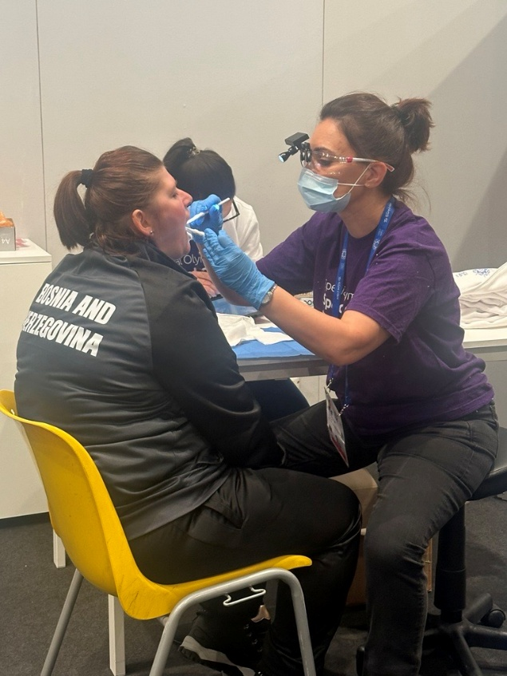

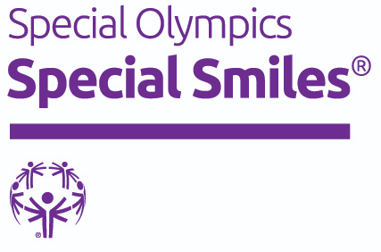

Special Olympics Healthy Athletes
Special Smiles®
Clinical Director Manual

Table of Contents
What is Special Smiles®..................................................................................................2
Why Special Smiles ®......................................................................................................2
Significance of Special Smiles® Screening.......................................................................4
Clinical Director Requirements........................................................................................5
Clinical Director Expectations, Role, & Checklist..............................................................5
Roles & Training of Special Smiles Volunteers..................................................................8
Obtaining Equipment, Resources, and Materials............................................................12
Set Up, Breakdown………………......................................................................................13
Floorplan/Layout………….………..……………………………………………………………………………14
Station/Volunteer Matrix...............................................................................................16
Station 1: Check In.......................................................................................................16
Station 2: Screening.....................................................................................................17
Station 3: Mouth Guard (Optional).................................................................................18
Station 4: Fluoride Varnish (Optional)............................................................................19
Station 5: Oral Hygiene Instructions..............................................................................19
Station 6: Check Out....................................................................................................20
Building a Referral System............................................................................................22
Screening Data and Post Event Evaluation.....................................................................22

What is Special Smiles®?
Special Smiles has an important history. Special Smiles began in 1994, serving as the first Program of Special Olympics Healthy Athletes. The awareness of Rosemary Kennedy's dental concerns brought attention to the oral health issues for people with intellectual and developmental disabilities.
The Special Smiles discipline of Healthy Athletes provides comprehensive oral health care information, including free dental screenings and instructions on correct brushing and flossing techniques to Special Olympics athletes. Volunteer dental health professionals and students perform oral health screenings, oral hygiene instruction, mouthguard adaptation, and apply fluoride varnish for athletes participating in the screening. Special Smiles has demonstrated remarkable success in creating awareness and improving access to dental care for people with intellectual and developmental disabilities (IDD).

Why Special Smiles®?
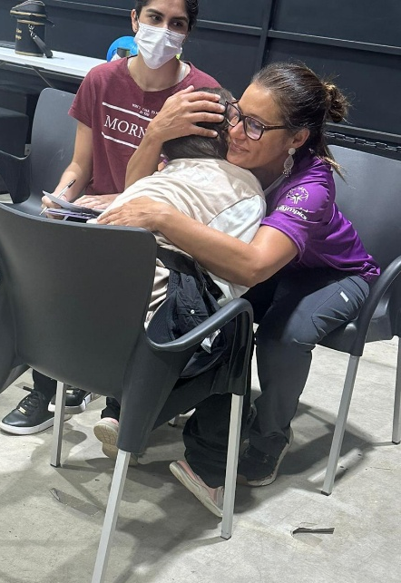
Oral health problems are present in many people with disabilities. Therefore, the Special Smiles screening aims to improve access to dental care for people with IDD and to raise the public and dental community’s awareness of the oral health problems that many of those with intellectual and developmental disabilities may face.
With that aim in mind, the Special Smiles screening focuses on understanding the needs and enhancing the oral hygiene habits of people with IDD, identifying oral health concerns and risk factors for chronic conditions, and linking Special Olympics athletes to necessary dental care in their communities. To accomplish this, the following items are focused on throughout the screening:
Trauma or Pain
Trauma can result from poor oral health habits (grinding, tongue thrusting, etc.). It can also result from sports-related injuries. Unfortunately, trauma can also result from abuse. Documenting trauma of all types is important to understanding the trauma present with Special Olympics athletes and who to engage to address it.
Oral Hygiene Habits
Understanding oral habits typically improves oral hygiene, but manual dexterity plays a role in that relationship as well. We want to understand how often Special Olympics athletes are cleaning their mouth. Understanding Special Olympics athletes' oral habits, both good and bad, helps us to provide tailored education to meet their specific needs.
Oral Hygiene
Oral hygiene in this population may be poor and is caused by many factors. Examples of external factors may include athlete dexterity, support system, frequency of dental visits, dental education of the athlete, and dental education of the support system.
Periodontal Health
Periodontal health has a bidirectional relationship with oral habits, oral hygiene, state of the dentition, general health, and systemic chronic conditions. Individuals with IDD have a higher rate of gingivitis and periodontal disease.
Number of Cavities
Due to a variety of factors and barriers, the prevalence of untreated dental issues is higher among people with IDD.
Regular Access to Preventative Measures
Oral health is the number one unmet healthcare need in individuals with IDD. Therefore, it is important to promote and support Programs in linking people with IDD to continuity of care.
Sufficient Education for Athletes and Support Systems
Each person has a different dentition. Learning how to best maintain oral hygiene occurs during each interaction with a dental professional. The directions may change as each person, person’s dentition, and/or person’s support system change. Special Smiles provides interactions with dental professionals that offer educational opportunities for the athletes, including demonstrations and/or supervision of the person practicing oral hygiene techniques.
Also consider educating athletes and their support systems on the connections between oral health and overall health. Poor oral health can cause significant issues to overall health, and oral health issues often stem from an individual's personal behaviors. Poor oral health is associated with other chronic illnesses, such as diabetes and heart disease. Oral disease is also linked with behaviors such as using tobacco and consuming sugary foods and beverages. Diabetes clearly increases the risk of periodontal diseases, and biologically plausible mechanisms have been demonstrated in abundance.

Significance of Special Smiles®
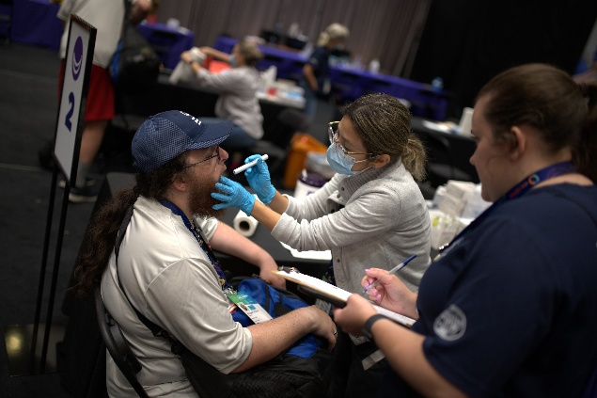
Oral health screenings are an integral part of Special Smiles. These screenings identify Special Olympics athletes’ oral health concerns and aims to link them to care in their community and reduce dental anxiety. The screening additionally collects oral health data specific to people with IDD. This screening was meticulously built over several years through direct input from dental providers, educators, and researchers from all over the world. The addition of validated questions came from sources such as the National Health and Nutrition Examination Survey (NHANES) and the Decayed, Missing, Filled Teeth (DMFT) index.
Special Smiles events educate dental professionals and students to care for people with IDD and prepare them to be more inclusive in clinical practice while contributing to a network of oral health professionals to serve people with IDD.

Clinical Director Requirements
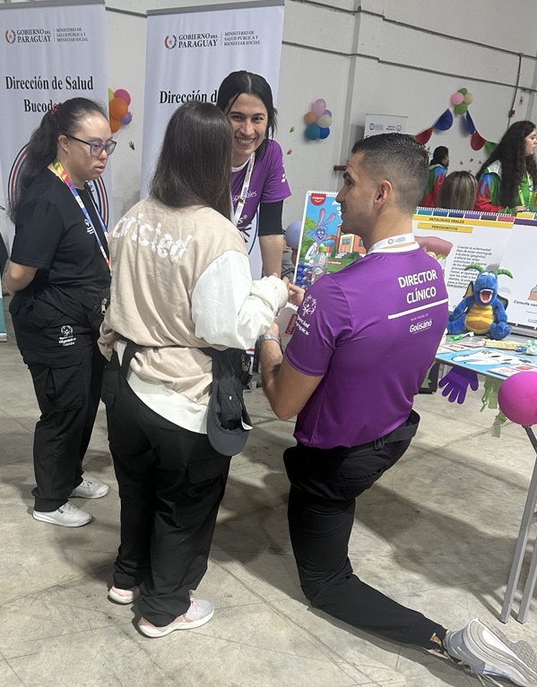
Current licensure as a Dentist or Dental Hygienist in the state/region/country where Special Smiles events will take place.

A minimum three-year commitment to ensure quality and continuity of the Special Smiles Program.

Complete the Clinical Director blended learning online training and in-person experience at a Special Smiles screening with an approved mentor

Clinical Director Expectations, Role, and Checklist
The role of the Special Smiles Clinical Director includes but is not limited to:
- Determining Event Opportunities
Identifying and scheduling Special Smiles screenings is a joint effort between the Clinical Director and their local Special Olympics Program. Building professional relationships and connecting with the local community will help deliver a successful Special Smiles event. Events may be either stand-alone or in conjunction with local Program competitions.
- Understanding Special Smiles stations and screening components:
Each of the Special Smiles screening stations: Check In, Screening, Oral Hygiene Instructions, Mouthguard, Fluoride Varnish application, Check Out require a variety of materials and a minimum number of volunteers and volunteer types to operate successfully. These stations will be reviewed in detail later in this document.
- Recruiting and training volunteers
Work with the Program to form a team of clinical and general volunteers. Clinical Directors are best positioned to identify and train dental professionals to serve as clinical volunteers in Special Smiles. Recruit ample numbers of clinical and non-clinical volunteers to support the screening based on the space and number of athletes expected. Provide adequate training to ensure volunteers can carry out their role at each station of the screening. Sometimes volunteers will work in shifts. If this occurs, ensure you go over screening protocols and review instruments/equipment prior to the beginning of each shift. When possible, it is recommended to prioritize identifying volunteers that can commit to full day shifts. Allow for a minimum of 1 hour for volunteer training before the event start time. This training time should include tablet login, overview of the screening flow, and introduction to screening procedures and protocols. It is imperative that the Clinical Director expresses to volunteers the importance of completing screenings in their entirety. It is the responsibility of the Clinical Director to ensure that all screening forms and tablet-based screenings are completed fully.
Potential volunteers may come from:
- Private practices
- Universities/Colleges/Schools
- Health and professional associations
- Medical facilities
- State and local public health agencies
Clinical volunteers are any volunteers that can:
- Perform the screening
- Record the screening
- Deliver oral hygiene instructions
- Fabricate the mouthguard
- Apply the fluoride varnish
Examples of clinical volunteers include:
- Dentists
- Dental Hygienists*
- Dental Assistants *
- Dental Hygiene students**
- Dental students**

*Some licensed professionals may be able to perform other clinical roles or may require a certain level of supervision from a licensed dentist. Check with your local dental license board to determine how else they may contribute to your Special Smiles® screening.

**Dental and dental hygiene schools determine the parameters for their students to participate and typically require the presence of a school faculty member.
General volunteers cannot perform clinical volunteer roles, although clinical volunteers may be assigned general volunteer roles. These roles include:
- Check in/out
- Athlete flow and HAS history assistance
- Distribution of oral hygiene products

- Obtaining necessary equipment, supplies, and materials
Needed supplies & equipment may be available to Clinical Directors through donations or loans obtained by networking with local sponsors, private practices, and health services. If local sources are not available specific equipment & supplies can be requested through SOI.
- Managing the Special Smiles screening and set-up and breakdown of event venue
The Clinical Director is responsible for supervising the set up and delivery of the Special Smiles screening, ensuring all protocols are followed. At the completion of the screening, the Clinical Director is responsible for overseeing the breakdown and proper packing of equipment and supplies for the Special Smiles event. It is recommended that equipment and supplies are packed and labeled by screening station for easy packing and identification once stored. Laminated lists taped to the lid of each bin are helpful for proper packing, storage, and keeping inventory. It is recommended that you allow 1-2 hours for screening set up and 1 hour for screening breakdown.
- Collecting and reporting data and overseeing referral recommendations
Post-event evaluation is critical information needed to continuously improve and adapt the screening to the needs of the athlete. The Clinical Director is responsible for collecting screening numbers, number of mouthguards distributed, number of athletes who received fluoride varnish applications, number of clinical and general volunteers, and number of referrals by type (urgent, non-urgent).

Clinical Director Checklist
- Contact local dental professionals about the date and location of the event and invite them to participate
- Contact your state or country association to check for restrictions or requirements when conducting a dental screening
- Coordinate with the Program so that you are aware of the athlete’s competition schedule, plan accordingly with adequate clinical and general volunteers
- Connect with your health Program manager to identify the necessary equipment/supplies order. Submit at least 30 days prior to your scheduled event to ensure delivery times and appropriate supply needs. Mouthguards and educational models can be requested through the Special Smiles PNF Form. Supplies such as gloves, masks, mouth mirrors, etc. are requested by the Program through Henry Schein, local stores, or online stores. The link to the Henry Schein portal is located on the Special Smiles Resources page under “Equipment and Supply List”.
- Overseeing set up and breakdown, it is recommended that you have individual bins clearly marked and inventory is taken pre and post event.
- Source equipment locally first from schools, colleges, distributors etc.
- Clinicians will need to bring their own loupes if desired. Mouth mirrors, pen lights, tongue depressors, gloves, masks, etc. are ordered by the Program through Henry Schein.
- Contact your state or country professional association to recruit clinical volunteers from your state or country.
- Contact potential supporters for give aways such as toothbrushes, floss, etc. from local source(s) school, colleges, distributors, local labs etc.
- Ensure that you have the hold harmless agreement and that all volunteers have signed daily and their shifts are recorded. It’s recommended that you assign a volunteer to this task if you have set rotating schedules for volunteers.
- Your local Program is responsible for collecting athlete informed consent forms. Included in this form is permission to take photos of athletes participating in the screening. You may take pictures of athletes and volunteers unless an athlete requests not to; please be respectful of athletes.

Needed forms/available resources:
- Special Smiles Equipment/Supplies list
- Special Smiles Athlete Report and Recommendations Card
- Hold Harmless Form

These forms and resources can be found at the bottom of the Special Smiles Resources page under “Event Resources and Equipment.”

Roles and Training of Special Smiles Volunteers
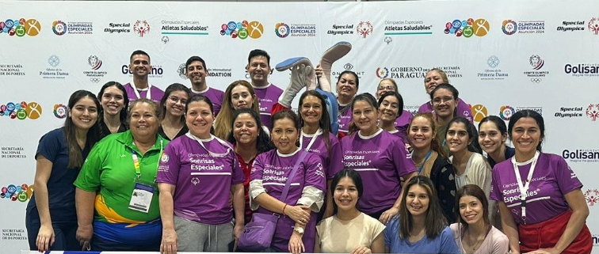
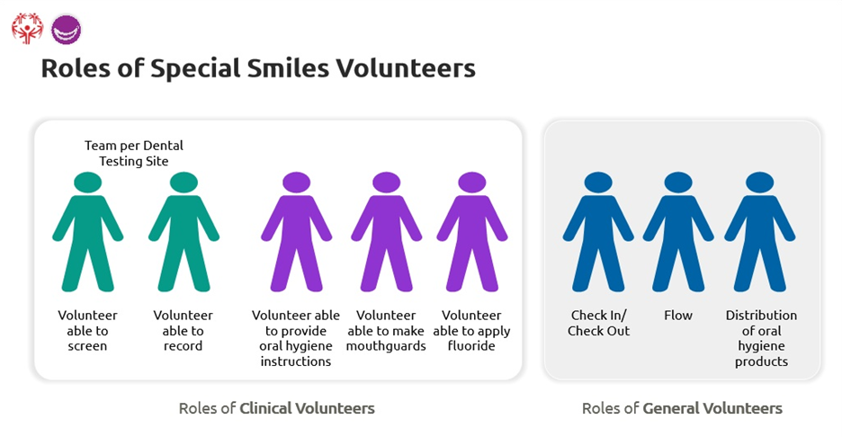
Special Smiles® screenings require numerous roles within the clinical and general volunteer groups.
General volunteers do not need to be licensed or have clinical experience in dentistry.
The Clinical Director can think about their general volunteers as fulfilling the following roles:
- Check In and Check Out
- Athlete flow and HAS health history assistance
- Distribution of oral hygiene products
The Clinical Director can think about their clinical volunteers fulfilling the following roles:
- Screening
- Recording
- Provide oral hygiene instructions
- Make mouthguards
- Apply fluoride varnish
There are always two clinical volunteers at each testing (screening) site in the Screening station. The volunteer who conducts the oral health screening will identify and report findings and conditions to the volunteer recording data on the HAS form. These roles work as a team at what is called the testing site. One volunteer performs the screening, and another volunteer simultaneously records the findings.
Be sure that clinical volunteers are given the opportunity to practice prior to the event starting and stay close to assist and correct when needed, especially at the beginning of the event and beginning of shift/volunteer changes.

Check In/Check Out
The Check In volunteer can be general or clinical and helps the athlete register and may direct athletes to the waiting area between screenings. In times of extreme screening volume, the Check In volunteer is encouraged to direct athletes to move between Healthy Athlete disciplines to support a quality event flow.
The responsibility of Check Out volunteer is to review the HAS form to ensure it has been completed in its entirety and a referral type has been indicated. Every athlete will receive a referral of “routine follow up”, “non-urgent,” or “urgent. The only exception is in instances when the athlete is unable to finish the screening. This should be indicated on the HAS form/tablet. The Clinical Director should review and ensure completion of every HAS form/tablet screening.
Flow
General volunteers may also assist athletes with navigating the screening venue as they move between stations and waiting areas. When this volunteer is stationed in the waiting area between Check in and Screening, they may be asked to assist the athlete with their HAS dental history section. This is important, since the dental history should be completed after the Check In station, but before the Screening station.

Distribute oral hygiene products
Another role of the general volunteer is to distribute oral hygiene products to athletes, near the OHI station or Check Out. They should be prepared to identify and distribute products to meet both general and specific needs of athletes as instructed by a clinical volunteer.

As the Clinical Director you are responsible for providing training to the volunteers on their specific roles and responsibilities at each station of a Special Smiles event. This includes:
- Training clinical volunteers to screen according to Special Smiles Standards,
- Reviewing basic etiquette of working with persons with IDD, and
- Discussing commonly asked questions and emergency protocols

Volunteer able to screen
The volunteer able to screen is a licensed clinical volunteer who will be able to conduct all aspects of the Special Smiles screening stations, including those where engagement with the oral cavity may be indicated. The volunteer who conducts the oral health screening will identify and report findings and conditions to the volunteer recording data on the HAS form.
It is very important for this volunteer to work with a well-trained clinical volunteer able to record. The volunteer able to record is dedicated to collecting and reporting accurate information on each athlete screened. This volunteer prompts the clinical volunteer performing the screening through the correct screening sequence to ensure nothing was missed.
Volunteer able to record
The volunteer able to record is dedicated to collecting and reporting accurate information for each athlete screened on the Special Smiles HAS form. This volunteer prompts the clinical volunteer performing the screening through the correct screening sequence to ensure nothing was missed. The volunteer able to record may not need to be licensed. This is a great opportunity to engage undergraduate students.
Volunteer able to provide oral hygiene instructions
This volunteer should be well educated in oral hygiene and oral hygiene habits. They should be prepared to educate the athlete on general oral health information and products as well as topics specific to the athlete (as specified by other clinical volunteers or self-identified). This clinical volunteer may engage in demonstrations and supervision of the participant practicing an oral hygiene technique to encourage positive changes in oral hygiene habits. Some topics this volunteer should be prepared to educate on are:
- Routine brushing and flossing
- Cavities and restorations
- Periodontal disease (such as gingivitis or periodontitis)
- Preventing trauma
- Cleaning partials and dentures
- Adaptive oral hygiene tools
- Periodontitis and diabetes
- Over-retained primary teeth
Volunteer able to make mouthguards
The mouthguard station is an optional station. This volunteer selects, heats, and adapts the mouthguard to the athlete's mouth. This volunteer will also ensure that the guard is set in the molded position and then provide the mouthguard to the athlete. They should be trained to educate the athlete on keeping up with the mouthguard and keeping it clean. If your screening defers this responsibility to the Oral Hygiene Instruction station, make sure it is clearly communicated between stations.
Volunteer able to apply fluoride
The fluoride station is an optional stop. Most clinical volunteers can apply fluoride when under the supervision of an onsite dentist. Fluoride application is a preventative measure that is helpful to the athlete but inhibits visualization of the oral cavity, demonstration with OHI, and fabrication of the mouthguard. Clinical volunteers able to apply fluoride must be well trained on the application of fluoride to a reasonable dry field, the flow of the event, and ensure that application of fluoride occurs after other clinical volunteer stations are completed. This volunteer should know when the athlete is able to eat and drink after fluoride application and if there are other limitations or restrictions after fluoride application.

As the Clinical Director you are responsible for providing training to the volunteers on their specific roles and responsibilities at each station of a Special Smiles event. This includes:
- Training clinical volunteers to screen according to Special Smiles® standards and protocol
- Reviewing basic etiquette of working with persons with IDD
- Discussing commonly asked questions and emergency protocols

Be sure that clinical volunteers are given the opportunity to practice prior to the event starting and stay close to assist and guide when needed.

Obtaining Equipment, Resources, and Materials
When it comes to equipment, supplies and materials, Clinical Directors need to consider what will be needed for their event. A complete list of recommended equipment, supplies & materials can be found on the Special Smiles Resources page, but some additional things to consider include:
- The need for mirrors at multiple stations
- The need for multiple glove sizes
- How supplies may be affected based on the number of athletes with mixed dentition and/or limited opening
- What equipment will be required to make the Special Smiles layout fit in available space, including how to separate testing sites and where power sources will be located, impacting where certain stations can be placed

Clinical Directors should work closely with the local Special Olympics Program staff to ensure all equipment, supplies and materials can be ordered and secured for the event. It is recommended all supplies are requested and/or ordered at least 90 days in advance.

Set Up, Breakdown, & Floorplan
Setting up for Special Smiles
Clinical Directors are expected to understand what will be needed to set up for a Special Smiles event. It can be helpful to take a picture of the venue prior to the event to help plan for set up. You will need to coordinate logistics with the Special Olympics Program staff to confirm:
- The length of time to create the Special Smiles layout
- When equipment and/or supplies arrive at the venue
- When set up in the venue can begin
- How many additional volunteers, if any, will be needed to complete set up

When possible, setting up the day before is helpful. However, if you are unable, you will need to build in extra time before the venue opens to athletes.

Breaking down after Special Smiles
Clinical Directors are expected to break down the Special Smiles layout after all the screenings have been completed for the event. If your event is multiple days, this will be completed after the final day of screening. Discuss with the Special Olympics Program staff:
- How long break down will take
- When the venue closes
- When Special Smiles should take their last athlete for screening
- Where to store the remaining supplies and/or equipment
- Where all collected trash is to be disposed of

If you need volunteers to assist with breakdown, be sure to schedule this ahead of time with any available volunteers. Once the event has concluded, the Clinical Director will then work with the scheduled volunteers and Special Olympics Program staff to complete breakdown and return the venue to pre-screening condition. You can use the picture of the venue you took prior to setting up to ensure this is done appropriately.

Special Smiles Floorplan/Layout

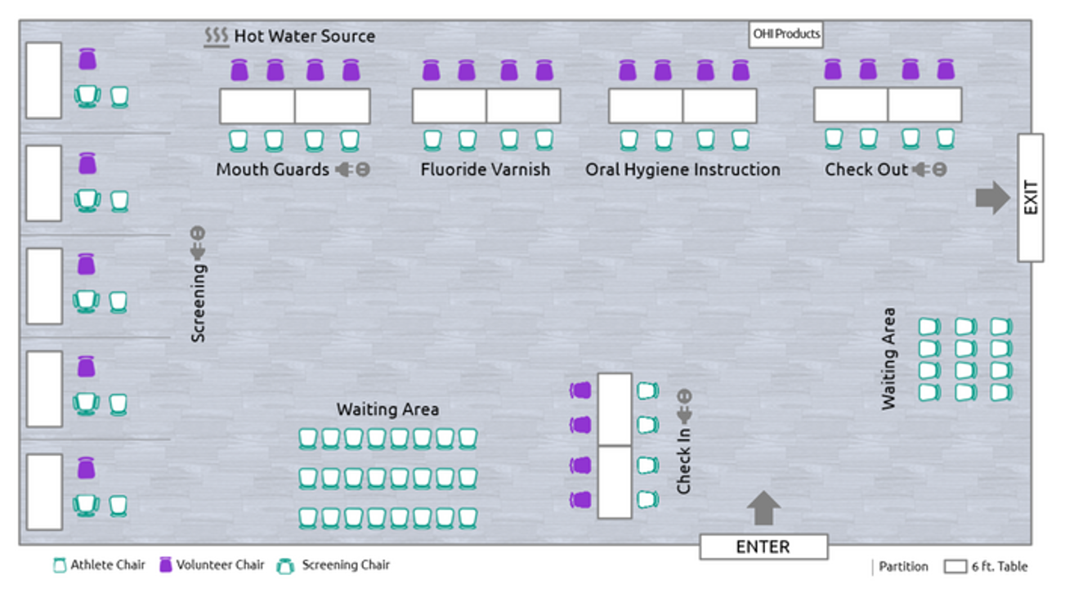

The Special Smiles screening consists of six stations: Check In, Screening, OHI, Mouthguard, Fluoride, and Check Out. The Fluoride and Mouthguard stations are optional.
The placement of these stations is up to the discretion of the Clinical Director. Station locations are often dependent upon the size of the venue, the number of volunteers performing screenings, volunteers recording, and the number of athletes expected.

Station/Volunteer Matrix

Special Smiles
Station Title | Estimated # Testing Sites | Estimated # Volunteers | General | Clinical | Notes/Specifications
Station 1: Check In | 4 | 4 | 4 | --- | General volunteer or dental/hygiene student
Station 2: Oral Screening | 5 | 10 | --- | 10 | 10 Clinical volunteers per testing site (5 to screen and 5 to record)
Station 3: Mouth Guards | 4 | 4 | --- | 4 | Clinical: Dentist/hygienist based on license, student with supervision
Station 4: Fluoride Varnish | 4 | 4 | --- | 4 | Clinical: Dentist/hygienist based on license, student with supervision
Station 5: Oral Hygiene Instruction | 4 | 4 | --- | 4 | Clinical: Dentist/hygienist, student
Station 6: Check Out | 4 | 4 | 3 | 1 | Clinical Director and dental/hygiene student or general volunteer
Total Volunteers |  | 30 | 7 | 23 | Combined total = 60

The above volunteer matrix considers the number of clinical and general volunteers needed at a Special Smiles event screening approximately 200 athletes per day. Please alter your volunteer numbers based on the number of athletes you expect to screen at each specific Special Smiles event you hold.

Station 1: Check In
Athletes check in for the Special Smiles screening here. Then, athletes are directed to complete the athlete portion and dental history of the HAS form in a Waiting Area. General volunteers are used at Check In and in the Waiting Area. The general volunteers at Check In will be at a table to start the Check In process with athletes; while the general volunteers, stationed in the Waiting Area, assist athletes with completing the health history section of the HAS form. Once this is completed, the athlete can be called to the first available testing site at the next station.
Volunteers Needed: 4 general volunteers or dental/hygiene students
Supplies Needed: Clipboards, pens, printed HAS forms bin/storage for paper HAS forms, pre-printed labels for HAS forms, tablets & chargers (if being used), Special Smiles banners and entrance signage.
Program Tip: If using printed HAS forms, it is recommended that you pre-print labels from GMS or other athlete registration software to affix to the top of the HAS form for a quicker check-in process.
Clinical Director Tip: Ensure volunteers are instructed on how to affix the HAS labels (paper only), utilize tablets, and are prepared to help athletes completing this section. Tablets will ‘follow’ the athlete throughout the screening process so ensure you give instructions to volunteers on best practices for ‘handing off’ to the next station.
Check In Station Tips:
- Ensure label is affixed to the top or all identifier/demographic questions are fully completed
- Ensure all sections of the “Athlete Reported Medical and Dental History” are fully completed
- If indicated, help athletes identify (as closely as possible) a month and year that they experienced a dental injury, identify the time since their last dental visit, etc.

Station 2: Screening
Once athletes leave Check In, they are directed to Screening. Athletes have their oral hygiene and overall oral health screened at this station. The presence or absence of signs of conditions are then recorded. The area and volunteers that can accommodate an athlete screening is called a testing site. Each testing site is staffed with a volunteer able to screen and a volunteer able to record. Both the volunteer that screens and the volunteer that records are considered clinical volunteers in most cases.

Volunteers Needed: 10 clinical volunteers per testing site (to screen and record). For a 100-athlete event, 5 clinical volunteers to screen and 5 clinical volunteers or dental/hygiene students to record.

Supplies Needed: pens, gloves, masks, mouth mirrors, tongue depressors, gauze, 4 small trashcans with trash bags, tablet chargers (if using), bins for supplies storage
Program Tip: Consider holding a virtual volunteer pre-event meeting to inform clinical and general volunteers on what to expect (parking, lunch, attire, etc.), best practices, and protocols to ensure a successful Special Smiles screening. For volunteers who don’t have prior experience providing care to individuals with IDD, consider utilizing our online learning portal for additional pre-event education. This learning portal is especially helpful and highly utilized among dental/dental hygiene student volunteers.
Clinical Director Tip: Ensure volunteers are instructed and calibrated on screening responses before and during any shift changes. Remind screeners/recorders to double check every question/box has been completed before sending athlete to the next station.
Screening Station Tips:
- Ensure a response is recorded for every question whether the answer is yes, or no.
- Ensure the clinical volunteer completing each section of the screening records their name at the top of their assigned section.
- When asking the athlete about past dental trauma, it is ok if they can’t exactly remember when it occurred – help them do their best to narrow down a month and year.
- If desired, identified areas of untreated decay or other oral conditions that need referral for treatment (including suspicious lesions during the oral cancer screening), can be recorded detailed (red/white lesion, decay #28DO, etc.) in the notes of the urgent/non-urgent referral section of the Check Out station.
- Record tooth mobility that is Class 2 or higher. Determine utilizing two mouth mirror ends or tongue depressor and mouth mirror.
- Utilize the note sections provided to record additional information as needed.
- When completing the “Decayed, Missing, Filled teeth” component of the “Dentition” section, only record teeth that are missing due to decay/disease. Do not record teeth removed for orthodontics or 3rd molars.
- In the “Over Retained Primary Teeth” section, consider athlete age to record any instance of over retained deciduous teeth including retained primary teeth due to lack of permanent replacing dentition (we cannot confirm with x-rays but can make educated inferences).
- In the “Station Designation” section, if Mouth guard and Fluoride Varnish sections are not being offered at your event, there is no need to mark them as recommended.
- Every athlete should have tailored Oral Hygiene Instructions. Reference responses from the “Oral Health Care Habits”, “Oral Hygiene”, and “Periodontal Health” sections.

Station 3: Mouth Guard (Optional)
At this optional station, clinical volunteers provide athletes a ‘boil and bite’ style mouthguard and give instructions on how to care for it. Mouthguard-specific supplies should be positioned closest to a heating source (such as a microwave, hot plate, or electric kettle). While most clinical volunteers are able to adapt mouthguards under the supervision of an onsite dentist, they must be well trained in mouthguard sizing, heating, adaptation, and providing education on how to clean and care for the mouthguard. In some cases, it may be appropriate to move mouthguard fabrication to be included within the OHI station. If this is the case, be sure this is communicated to all volunteers.
Volunteers Needed: 4 Clinical volunteers or dental/hygiene students
Supplies Needed: pens, mouthguards, mouthguard cases (if acquired via partner donation/VIK), electrical outlets and electrical power strips, microwaves/kettles, water /water pitchers (if using kettles), gloves, masks, tablet chargers (if using) bin for storage of equipment.
Program Tip: This is a common station to experience ‘bottle necking’ of athlete flow. Consider utilizing the waiting area to eliminate athletes standing in a long line that disrupts continuity.
Clinical Director Tip: Ensure volunteers are instructed on the type/brand and sizes of mouthguards they have and fitting requirements/best practices.

Mouth Guard Station Tips:
- In the “Mouth Guard” section, mark “no” to the question “is this station offered at the Special Smiles screening” if your event is not offering this service.
- If a mouth guard is provided at the Special Smiles event, the screener should provide mouth guard care and use instructions at the “Mouth Guard” Station.

Station 4: Fluoride Varnish (Optional)
Fluoride varnish application requires a clinical volunteer and should only be applied after all stations except Check Out have been completed. Therefore, it can be applied either at its own station, as seen here, or at the end of the screening station. Once athletes have fluoride varnish applied to their teeth, volunteers should instruct them when activities such as eating and drinking are allowable.
Volunteers Needed: 2 Clinical volunteers or dental/hygiene students
Supplies Needed: pens, fluoride varnish, gloves, masks, 2 small trash cans with trash bags.
Program Tip: Use the printed post-fluoride varnish application instructions that come with fluoride varnish orders if wanting to provide athletes/caregivers with post application instructions.
Clinical Director Tip: Ensure volunteers are instructed on the type of fluoride varnish being offered and any application best practices.
Fluoride Varnish Station Tips:
- In the “Fluoride Varnish” section, mark “no” to the question “is this station offered at the Special Smiles screening” if your event is not offering this service.
- If fluoride varnish is provided at the Special Smiles event, the screener should provide post fluoride varnish application instructions at the “Fluoride Varnish” Station.

Station 5: Oral Hygiene Instructions (OHI)
Athletes are then directed to the Oral Hygiene station and provided information about how to improve their oral health based on general information and specific needs. The type of volunteer needed at this station is clinical. While most clinical volunteers can give oral hygiene instructions under the supervision of an onsite dentist, you must ensure they are well trained in providing OHI such as explaining gum disease, causes of trauma to the mouth, cavities, and proper brushing/flossing including adaptive techniques. Once finished here, athletes will be directed to the Mouthguard or Fluoride station. If you are not planning to have either optional station, athletes should be directed to Check Out when finished with oral hygiene.
Volunteers Needed: 2 clinical volunteers or dental/hygiene students
Supplies Needed: pens, educational materials such as handouts and mouth models, OHI take-home products for athletes (toothbrushes, toothpaste, floss, etc.), bins for supplies storage
Program Tip: Consider creating ‘OHI take home’ bags for athletes prior to the event for easy distribution.
Clinical Director Tip: Ensure volunteers are instructed to utilize age-appropriate educational materials (i.e. use puppets for educating children/youth and mouth models for adults.
Oral Hygiene Instructions Station Tips :
- Consult selections from the “Determination of Oral Hygiene Instruction Needs” section. If any additional instruction is needed but not marked in this section, indicate it in addition in the “Oral Hygiene Instructions” station when checking which oral hygiene topics were provided to the athlete.

Station 6: Check Out
Once all stations, including optional stations, are completed, the athlete will be ready to head to Check Out. This station should ideally utilize one general or clinical volunteer and the Clinical Director. Check Out serves as an opportunity to confirm all Special Smiles stations were completed and a referral type, with rationale, has been indicated on the HAS form. The volunteer at Check Out is responsible for ensuring that the HAS form is completed and that the paper form or tablet has been collected, and that the athlete has received their personalized Report Card/Referral Sheet and if indicated a list of provider locations/options for receiving care.
Volunteers Needed: 2 general volunteers or dental/hygiene students and 1 Clinical Director
Supplies Needed: pens, electrical outlets and power strips, tablet chargers, printed Athlete Report and Referral Form, storage bin for supplies.
Program Tips: Consider utilizing Healthy Athlete Grant funding to support the temporary hire of a data entry staff when providing paper only screening events. Consider utilizing National Care Advisors partnership for urgent and non-urgent referral connection. Even in paper only events, consider having a volunteer with a laptop at this station to digitally track the names, contact info, and referral type of athletes as they are checked out as a method to efficiently and properly track follow up needs.
Clinical Director Tip: Ensure that you are checking printed and digital HAS forms at check-out for standardized and full completion. Work with your volunteers to ensure forms are completed entirely and to protocol standards.
Check Out Station Tips:
- If the athlete had to leave the screening area for any reason (ie competition schedule, lunch, etc.) and is unable to return please mark that the screening was incomplete and describe the reason.
- If the athlete must leave the screening area but is able to return, you may hold their form or digital screening and then complete upon their return.
- Mark “yes” for every athlete in the “follow-up recommended” section. Every athlete should, at minimum, receive a referral for routine follow-up with a dental provider
- Please indicate the athlete’s referral type based on their highest level of need.
  - For example, an athlete may need a routine dental cleaning but also needs a referral for untreated urgent decay needs. In this case, mark “dentist,” “urgent referral,” “decayed, missing, or filled teeth” and provide a name/location for the athlete to take the referral and indicate if a provider list was dispensed to the athlete.
- If an athlete needs a referral indicated for a healthcare professional other than a dentist (i.e. primary care physician, Ear, Nose, & Throat specialist, etc. mark “other,” write in the specialty/clinical professional, indicate whether the referral is non-urgent or urgent, write in the reasons for the recommendation, and provide a name/location for the athlete to take the referral and indicate if a provider list was dispensed to the athlete.

Building a Referral System
As the Clinical Director, it is important that you utilize your network and connections with other dental providers to build a referral system for athletes. Coordinate with your Special Olympics Program to determine current referral partnerships as well as areas for potential expansion to ensure that all athletes that are screened have options for receiving dental care.
If a provider list does not exist, please work with your Program to create a printable (or digitally provided) list of dental offices where athletes can receive dental care. This list should be provided to every athlete needing a referral. If one does exist, please work with your Program to keep this list updated and accurate.

Screening Data and Post Event Evaluation
Screening data may be captured in one of two ways: either by use of printable HAS forms or through the digital HAS data entry system. The Clinical Director should work with the Special Olympics Program to determine how paper form data will be stored, transported, and digitized post event. It is the responsibility of the Clinical Director to ensure completed HAS forms stay secure and private from the time of completion until they are turned into Program staff to prevent HIPAA violations.
Post-event evaluation information is critical information needed to continuously improve and adapt the screening to the needs of the athlete. The Clinical Director is responsible for collecting the following data points:
- Total screening number
- Number of mouthguards distributed
- Number of athletes who received fluoride varnish applications
- Number of clinical and general volunteers
- Number of athlete referrals by type (non-urgent, urgent)

This information must be reported to the Special Olympics Program to be submitted to SOI through the Healthy Athletes grant report. When feasible, Clinical Directors are encouraged to support Programs with the processing of care referrals within 2-weeks post event for non-urgent referrals and 1 week post event for urgent referrals.
The quality of data collected through the Special Smiles Healthy Athletes System, is dependent on the dedication to excellence of Clinical Directors. SOI uses this data to, quite literally, change the world. SO Program Clinical Directors and volunteers ensure the needle of health equity continues to move favorably for those with IDD.

If you have any questions or would like more information, please email the Special Smiles Sr. Clinical Manager at specialsmiles@specialolympics.org
To access all our Special Smiles Resources please visit the Special Smiles Resources page at https://resources.specialolympics.org/health/special-smiles

